**UNIT 4: EDA Analysis**

**1. mtcars**

data(mtcars)

mean_mpg <- mean(mtcars$mpg)

median_mpg <- median(mtcars$mpg)

get_mode <- function(v) {

uniq_vals <- unique(v)

freq <- table(v)

mode_vals <- uniq_vals[freq == max(freq)]

return(mode_vals)

}

mode_mpg <- get_mode(mtcars$mpg)

cat("Mean MPG:", mean_mpg, "\n")

cat("Median MPG:", median_mpg, "\n")

cat("Mode MPG:", mode_mpg, "\n")

**Output:**

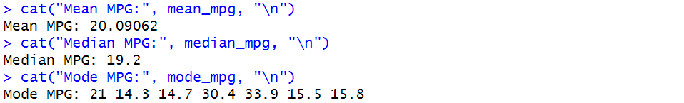

**2. Chick Weight**

data(ChickWeight)

sd_weight <- sd(ChickWeight$weight)

cat("Standard Deviation of Chickens' Weights:", sd_weight, "\n")

cat("The ChickWeight dataset does not contain gender information.\n")

heaviest_chicken <- ChickWeight[which.max(ChickWeight$weight), ]

cat("Heaviest Chicken:\n")

print(heaviest_chicken)

chick_count_by_age <- table(ChickWeight$Time)

cat("Number of Chickens in Each Age Group:\n")

print(chick_count_by_age)

**Output:**

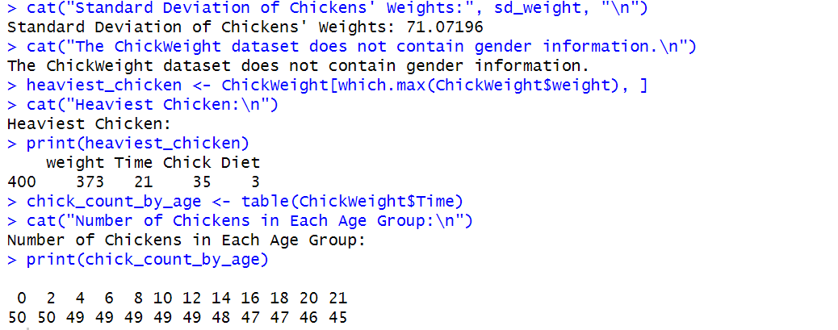

**3. Sepal Width**

data(iris)

quartiles <- quantile(iris$Sepal.Width, probs = c(0.25, 0.75))

Q1 <- quartiles[1] # First quartile (25th percentile)

Q3 <- quartiles[2] # Third quartile (75th percentile)

cat("First Quartile (Q1) of Sepal.Width:", Q1, "\n")

cat("Third Quartile (Q3) of Sepal.Width:", Q3, "\n")

**Output:**



**4. mtcars mean**

data(mtcars)

mean_mpg <- mean(mtcars$mpg)

cat("Mean of mpg in mtcars dataset:", mean_mpg, "\n")

**Output:**



**5. Read csv**

data <- data.frame(

ID = c(1, 2, 3, 4),

Name = c("Alice", "Bob", "Charlie", "David"),

Age = c(25, 30, 35, 40),

Score = c(90, 85, 88, 92)

)

write.csv(data, "sample_data.csv", row.names = FALSE)

read_data <- read.csv("sample_data.csv")

print(read_data)

**Output:**

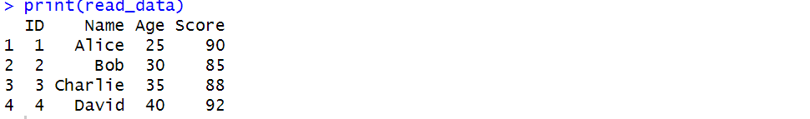

**6. Sepal Width**

data(iris)

quartiles <- quantile(iris$Sepal.Width, probs = c(0.25, 0.75))

Q1 <- quartiles[1] # First quartile (25th percentile)

Q3 <- quartiles[2] # Third quartile (75th percentile)

cat("First Quartile (Q1) of Sepal.Width:", Q1, "\n")

cat("Third Quartile (Q3) of Sepal.Width:", Q3, "\n")

**Output:**



**7. Width and length of rectangle**

calculate_area <- function(length, width) {

return(length * width)

}

rectangles <- data.frame(

length = c(5, 8, NA, 6, 10),

width = c(3, NA, 4, 7, 2)

)

rectangles$length[is.na(rectangles$length)] <- 1

rectangles$width[is.na(rectangles$width)] <- 1

rectangles$area <- mapply(calculate_area, rectangles$length, rectangles$width)

print(rectangles)

**Output:**

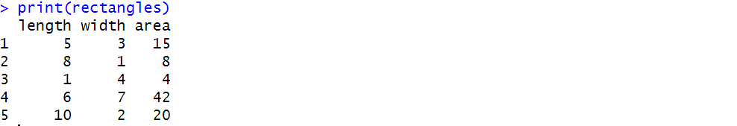

**8. Rectangle areas**

library(ggplot2)

calculate_area <- function(length, width) {

return(length * width)

}

lengths <- rep(1:10, each = 10)

widths <- rep(1:10, times = 10)

areas <- mapply(calculate_area, lengths, widths) # Compute area

rectangles <- data.frame(Length = lengths, Width = widths, Area = areas)

ggplot(rectangles, aes(x = Length, y = Width, fill = Area)) +

geom_tile() +

scale_fill_gradient(low = "lightblue", high = "red") +

labs(title = "Rectangle Areas", x = "Length", y = "Width", fill = "Area") +

theme_minimal()

**Output:**

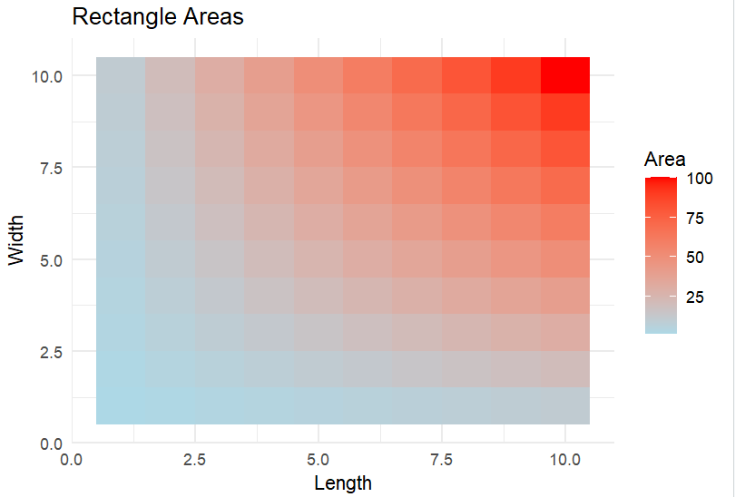

**9. minimum, maximum, range, variance, and standard deviation of the test scores**

scores <- c(85, 90, 78, 92, 88, 76, 95, 89, 84, 91,

87, 82, 90, 93, 88, 85, 77, 94, 80, 79)

min_score <- min(scores)

max_score <- max(scores)

range_score <- max_score - min_score

variance_score <- var(scores)

sd_score <- sd(scores)

cat("Minimum Score:", min_score, "\n")

cat("Maximum Score:", max_score, "\n")

cat("Range of Scores:", range_score, "\n")

cat("Variance of Scores:", variance_score, "\n")

cat("Standard Deviation of Scores:", sd_score, "\n")

**Output:**

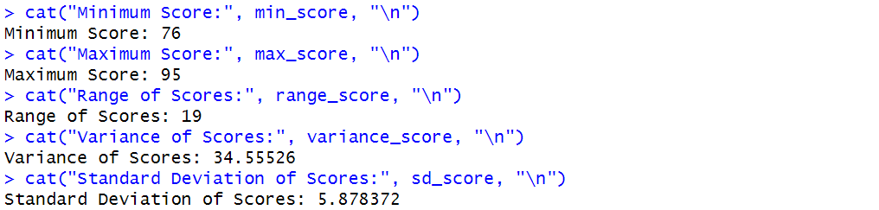

**10. covariance and correlation between advertising expenditure and sales revenue**

advertising <- c(1000, 1500, 2000, 2500, 3000, 3500, 4000, 4500, 5000, 5500)

sales <- c(15000, 18000, 21000, 24000, 27000, 30000, 33000, 36000, 39000, 42000)

cov_ad_sales <- cov(advertising, sales)

cor_ad_sales <- cor(advertising, sales)

cat("Covariance between advertising and sales:", cov_ad_sales, "\n")

cat("Correlation between advertising and sales:", cor_ad_sales, "\n")

**Output:**

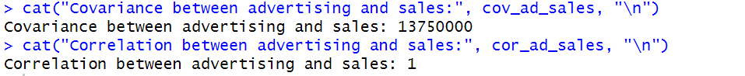

**11. Dataframe Stock X Stock Y**

stock_data <- data.frame(

Stock_X = c(0.02, 0.05, -0.01, 0.04, 0.03, 0.06, -0.02, 0.07, 0.01, 0.05),

Stock_Y = c(0.03, 0.04, 0.00, 0.05, 0.02, 0.07, -0.01, 0.06, 0.02, 0.04)

)

cov_stocks <- cov(stock_data$Stock_X, stock_data$Stock_Y)

cor_stocks <- cor(stock_data$Stock_X, stock_data$Stock_Y)

cat("Covariance between Stock X and Stock Y:", cov_stocks, "\n")

cat("Correlation between Stock X and Stock Y:", cor_stocks, "\n")

**Output:**

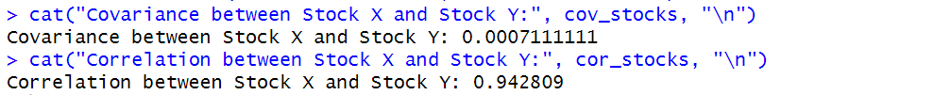

**12. Statistical measures**

library(dplyr)

performance_scores <- c(85, 90, 78, 92, 88, 76, 95, 89, 84, 91,

87, 82, 90, 93, 88, 85, 77, 94, 80, 79)

get_mode <- function(v) {

uniq_vals <- unique(v)

freq <- table(v)

mode_vals <- uniq_vals[freq == max(freq)]

return(mode_vals)

}

data <- data.frame(Performance_Scores = performance_scores)

summary_stats <- data %>%

summarise(

Mean = mean(Performance_Scores),

Median = median(Performance_Scores),

Mode = toString(get_mode(Performance_Scores)),

Minimum = min(Performance_Scores),

Maximum = max(Performance_Scores),

Range = max(Performance_Scores) - min(Performance_Scores),

Q1 = quantile(Performance_Scores, 0.25),

Q3 = quantile(Performance_Scores, 0.75),

Variance = var(Performance_Scores),

Standard_Deviation = sd(Performance_Scores)

)

print(summary_stats)

**Output:**

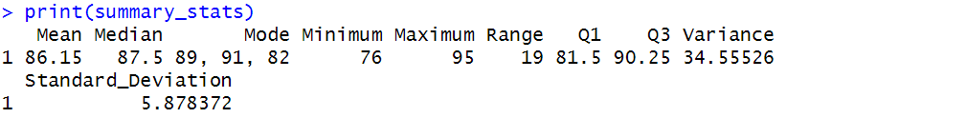

**13. Exam score box plot**

library(ggplot2)

exam_scores <- data.frame(

Class = rep(c("Class A", "Class B", "Class C", "Class D"), each = 10),

Score = c(85, 90, 78, 92, 88, 76, 95, 89, 84, 91,

87, 82, 90, 93, 88, 85, 77, 94, 80, 79,

65, 70, 68, 72, 74, 66, 75, 69, 73, 71,

55, 60, 58, 62, 64, 56, 65, 59, 63, 61)

)

quartiles <- quantile(exam_scores$Score, probs = c(0.25, 0.5, 0.75))

cat("Q1 (25th percentile):", quartiles[1], "\n")

cat("Median (50th percentile):", quartiles[2], "\n")

cat("Q3 (75th percentile):", quartiles[3], "\n")

ggplot(exam_scores, aes(x = Class, y = Score, fill = Class)) +

geom_boxplot() +

labs(title = "Exam Score Distribution by Class",

x = "Class",

y = "Score") +

theme_minimal()

**Output:**

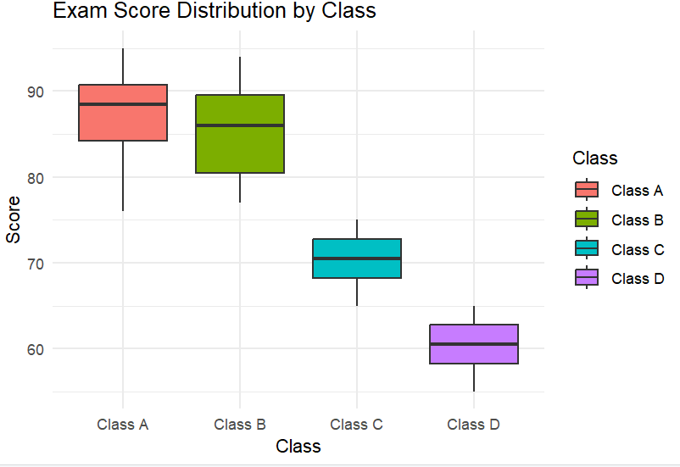

**14. EDA of patients**

library(dplyr)

library(moments)

patients_data <- data.frame(

Age = c(25, 30, 35, 40, 45, 50, 55, 60, 65, 70, 75, 80, 85, 90, 95),

Blood_Pressure = c(120, 125, 130, 135, 140, 145, 150, 155, 160, 165, 170, 175, 180, 185, 190)

)

get_mode <- function(v) {

uniq_vals <- unique(v)

freq <- table(v)

mode_vals <- uniq_vals[freq == max(freq)]

return(mode_vals)

}

eda_summary <- patients_data %>%

summarise(

Mean_Age = mean(Age),

Median_Age = median(Age),

Mode_Age = toString(get_mode(Age)),

SD_Age = sd(Age),

Skewness_Age = skewness(Age),

Kurtosis_Age = kurtosis(Age),

Mean_BP = mean(Blood_Pressure),

Median_BP = median(Blood_Pressure),

Mode_BP = toString(get_mode(Blood_Pressure)),

SD_BP = sd(Blood_Pressure),

Skewness_BP = skewness(Blood_Pressure),

Kurtosis_BP = kurtosis(Blood_Pressure)

)

print(eda_summary)

**Output:**

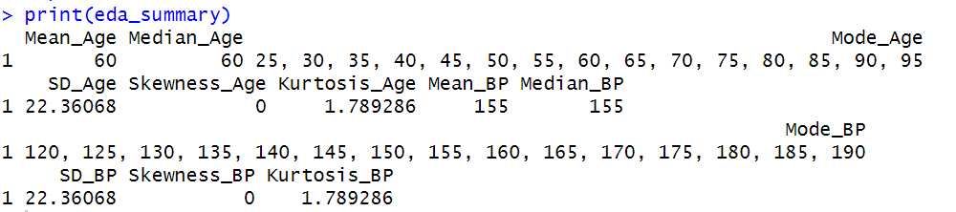

**15. Covariance and Correlation**

sales_data <- data.frame(

Products_Sold = c(50, 60, 45, 70, 90, 30, 80, 100, 55, 75),

Price = c(20, 18, 22, 15, 12, 25, 14, 10, 19, 13)

)

cov_sales_price <- cov(sales_data$Products_Sold, sales_data$Price)

cor_sales_price <- cor(sales_data$Products_Sold, sales_data$Price)

cat("Covariance between products sold and price:", cov_sales_price, "\n")

cat("Correlation between products sold and price:", cor_sales_price, "\n")

**Output:**



**16. Series of plots**

library(ggplot2)

library(gridExtra)

sales_data <- data.frame(

Products_Sold = c(50, 60, 45, 70, 90, 30, 80, 100, 55, 75),

Price = c(20, 18, 22, 15, 12, 25, 14, 10, 19, 13) # Product price per unit

)

hist_products <- ggplot(sales_data, aes(x = Products_Sold)) +

geom_histogram(binwidth = 10, fill = "blue", color = "black", alpha = 0.7) +

labs(title = "Distribution of Products Sold", x = "Products Sold", y = "Count") +

theme_minimal()

hist_prices <- ggplot(sales_data, aes(x = Price)) +

geom_histogram(binwidth = 2, fill = "green", color = "black", alpha = 0.7) +

labs(title = "Distribution of Product Prices", x = "Price per Unit", y = "Count") +

theme_minimal()

boxplot_products <- ggplot(sales_data, aes(y = Products_Sold)) +

geom_boxplot(fill = "blue", alpha = 0.5) +

labs(title = "Boxplot of Products Sold", y = "Products Sold") +

theme_minimal()

boxplot_prices <- ggplot(sales_data, aes(y = Price)) +

geom_boxplot(fill = "green", alpha = 0.5) +

labs(title = "Boxplot of Product Prices", y = "Price per Unit") +

theme_minimal()

scatter_plot <- ggplot(sales_data, aes(x = Price, y = Products_Sold)) +

geom_point(color = "red", size = 3) +

geom_smooth(method = "lm", se = FALSE, color = "blue") + # Trend line

labs(title = "Price vs Products Sold", x = "Price per Unit", y = "Products Sold") +

theme_minimal()

grid.arrange(hist_products, hist_prices, boxplot_products, boxplot_prices, scatter_plot, ncol = 2)

**Output:**

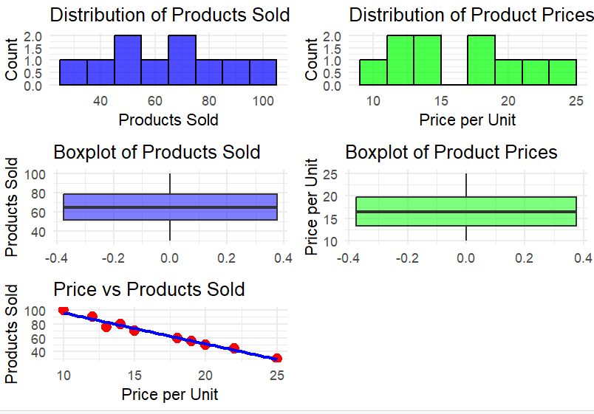

**17. Covariance, Correlation & Visualization**

library(ggplot2)

set.seed(123)

data <- data.frame(

Variable_X = c(10, 15, 20, 25, 30, 35, 40, 45, 50, 55),

Variable_Y = c(22, 29, 35, 45, 50, 60, 65, 72, 78, 85)

)

cov_xy <- cov(data$Variable_X, data$Variable_Y)

cor_xy <- cor(data$Variable_X, data$Variable_Y)

cat("Covariance between Variable_X and Variable_Y:", cov_xy, "\n")

cat("Correlation between Variable_X and Variable_Y:", cor_xy, "\n")

ggplot(data, aes(x = Variable_X, y = Variable_Y)) +

geom_point(color = "lightblue", size = 3) +

geom_smooth(method = "lm", se = FALSE, color = "pink") +

labs(title = "Scatter Plot of Variable_X vs. Variable_Y",

x = "Variable X",

y = "Variable Y") +

theme_minimal()

**Output:**

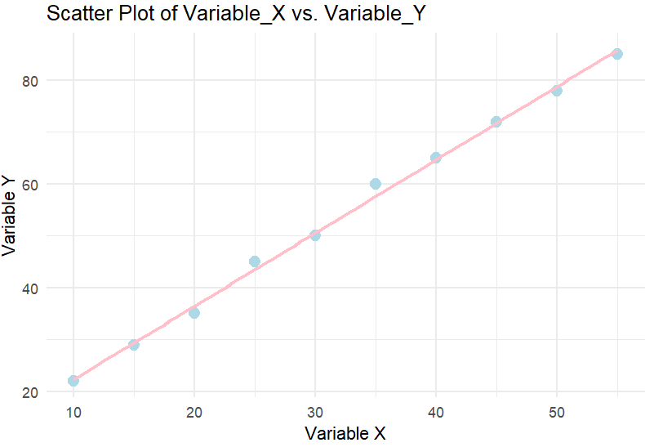

**18. Scatter plot with line trend**

library(ggplot2)

set.seed(123)

data <- data.frame(

X_Variable = c(10, 15, 20, 25, 30, 35, 40, 45, 50, 55),

Y_Variable = c(22, 29, 35, 45, 50, 60, 65, 72, 78, 85)

)

ggplot(data, aes(x = X_Variable, y = Y_Variable)) +

geom_point(color = "mediumturquoise", size = 3) +

geom_smooth(method = "lm", se = FALSE, color = "deeppink") +

labs(title = "Scatter Plot of X_Variable vs. Y_Variable",

x = "X Variable",

y = "Y Variable") +

theme_minimal()

**Output:**

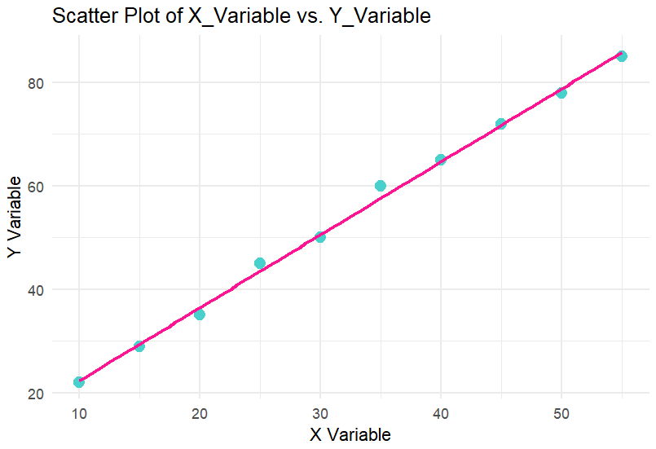

**19. Heatmap**

library(ggcorrplot)

set.seed(123)

data <- data.frame(

Variable_A = rnorm(100, mean = 50, sd = 10),

Variable_B = rnorm(100, mean = 30, sd = 5),

Variable_C = rnorm(100, mean = 75, sd = 15),

Variable_D = rnorm(100, mean = 60, sd = 8)

)

cor_matrix <- cor(data)

ggcorrplot(cor_matrix, method = "square", type = "lower", # "square" or "circle"

lab = TRUE, lab_size = 3,

colors = c("palegreen", "white", "lightpink"),

title = "Correlation Matrix Heatmap",

ggtheme = theme_minimal())

**Output:**

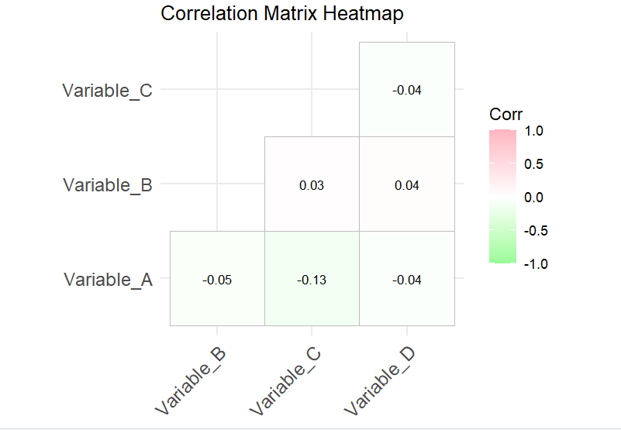

**20. Pair plot**

library(GGally)

library(ggplot2)

set.seed(123)

data <- data.frame(

Height = rnorm(100, mean = 170, sd = 10),

Weight = rnorm(100, mean = 70, sd = 15),

Age = rnorm(100, mean = 35, sd = 10),

Income = rnorm(100, mean = 50000, sd = 15000)

)

custom_theme <- theme(

panel.background = element_rect(fill = "gray95"),

panel.grid.major = element_line(color = "white"),

panel.border = element_rect(color = "black", fill = NA),

strip.background = element_rect(fill = "skyblue"),

axis.text = element_text(color = "black")

)

ggpairs(data,

upper = list(continuous = wrap("cor", size = 4, color = "red")),

lower = list(continuous = wrap("smooth", color = "pink")),

diag = list(continuous = wrap("barDiag", fill = "mediumpurple")),

title = "Pair Plot: Relationships Between Variables") +

custom_theme

**Output:**

